Soroptimist Garden Tour
May 20 & 21, 2023
13120 Lost Lake Road, Grass Valley, CA 95945

Welcome. I have lived on this 5-acre parcel for 16 years. In 2007 the property was thick with way too many trees of all sizes. In many areas it was not possible to see more than 20 feet into the woods. Trees, then and now, include Incense Cedar, Black Oak, Douglas Fir, Ponderosa Pine, Canyon Live Oak, Madrone, and Sugar Pine. I have seeded California Buckeye. Shrubs then included Whiteleaf Manzanita, and Deer Brush. There were no landscape plants back then.

This garden is true to our Foothill Woodland plant community. No palm trees, pansies, or privet for me. I am not a native-plant-only gardener, though I strongly favor natives and mostly use drought tolerant plants that are suitable to our climate and location.

Luckily this property does not have any Poison Oak, Scotch Broom, Himalayan Blackberry, Yellow Star Thistle, Periwinkle, Tree of Heaven, or English Ivy. I regularly do battle with Hedge Parsley, St. John’s Wort, Common Bedstraw, and Perennial Sweetpea, all of which are invasive non-natives.

As trees have been removed the increased light and air circulation have stimulated native wildflowers, grasses, sedges, shrubs, and certain weeds to appear and thrive. The deer-fence was added nine years ago. I regularly work to improve my firesafe management. Every year I thin out more of the forest and remove more trees back from the house. My goal is 20 or fewer trees per acre which would have been the original healthy-forest condition before non-indigenous people arrived.

I made all the garden gates which are self-closing. All except one do not have latches, and all open outward. My plants are secure until deer figure out how to grab hold and pull them open by themselves. My deer fencing works. Branches attached to the green drive through gates successfully discourage deer from jumping over. I constructed all the paths, steps, and rough rock berms. The soil here is quite rocky and drains very well. Erosion has never been a problem even in very wet years. I don’t do any fertilizing even to help plants get established. I rarely spray for anything. I installed the drip-only irrigation. In many cases irrigation is removed as plants mature.

Weiss Masonry constructed all the pretty rock and boulder walls. http://www.weissmasonry.comz
Pioneer Fence constructed the deer fencing. 510-337-0757

For both management and enjoyment of my property, it is key for me to walk the land very regularly, in all seasons and conditions. I look for things large and small. What has started to sprout or bloom? Where are weeds becoming an issue? Where might pruning be needed? What is thriving, or not? What animals are greeting me? Where will I find particular joy today? Yes, this garden takes work, on average 5-15 hours per week depending on the season.

There are spirits who watch over and protect my garden. These wardens mostly traveled here from Nepal and Papua New Guinea. One is from Peru. If you are observant, you may encounter all fourteen.

Please ask if you have any questions. I will be wearing a long-sleeved blue shirt and broad brimmed hat. Kern

Please have a Safe Garden Tour
- Not all areas and not all garden paths are suitable (safe) for all people.
- Please watch your step, for safety and so as not to trod on plants.
- Use your own good judgment.
- Please stay on the main garden paths and out of planted areas.
- Visit at your own risk.
Thank you for visiting.

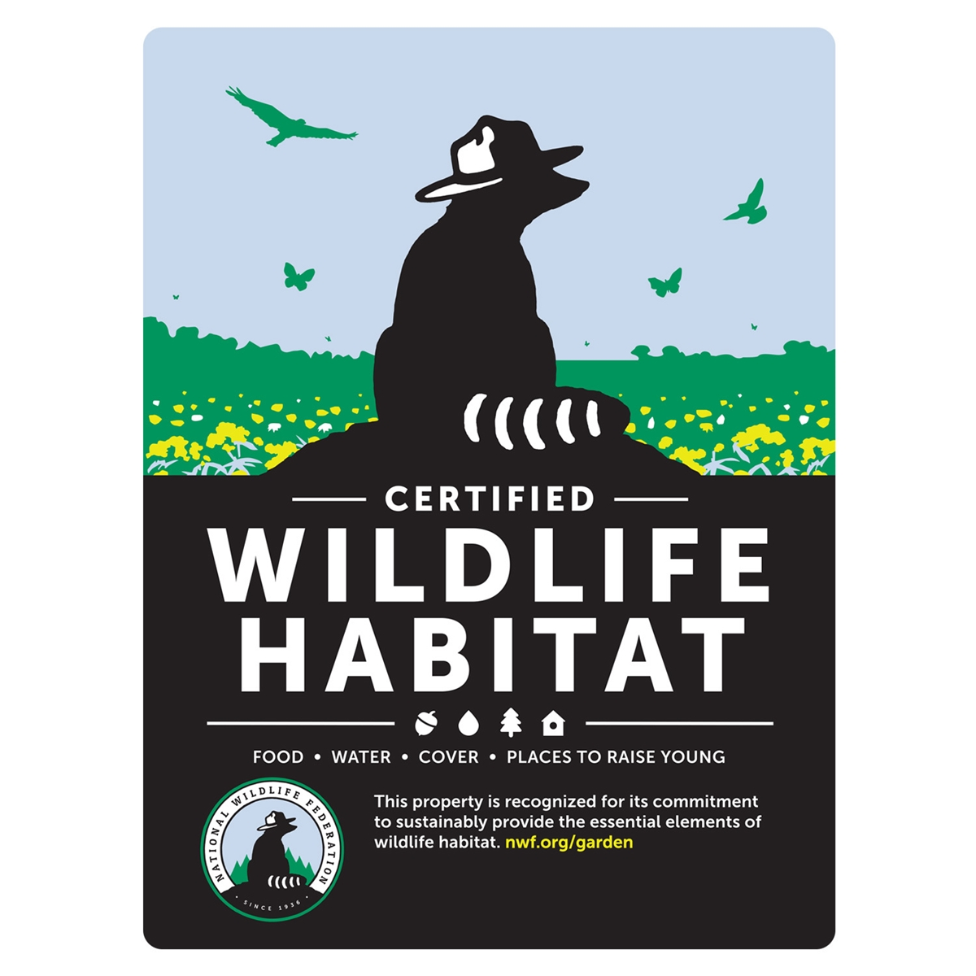

California Native Plant Society, Redbud Chapter
https://chapters.cnps.org/redbud/

National Wildlife Federation Certified Wildlife Habitat
https://www.nwf.org/CertifiedWildlifeHabitat/certify?source=WH18FSC

